Perl fast&easy® web development
Les Bate

Where Can I Get Perl?
Perl is available from a number of sources. The best known are http://www.activestate.com and http://www.perl.com.
I advise you not to download a ''development version" of Perl, as doing so may cause some confusion if you get any errors. Development versions of software are, as their name suggests, not final, fully debugged versions and may include bugs that could lead you to think that you had made a mistake in your code. For this reason, development versions of Perl are often referred to as "unstable." When you are more experienced in the use of Perl you may want to try development versions, in order to make use of new facilities provided, but until then it is best to stick to the latest "stable" version.
In addition to downloading Perl, you might want might want to look around at some of the resources available for Perl developers. Some useful Internet sites are given here, and there are more in Appendix B.
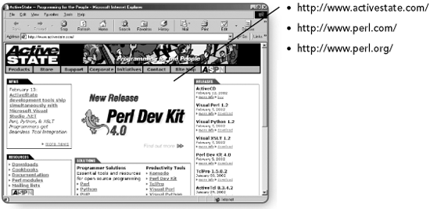

Print Formatting
Before you can achieve anything very exciting with your Perl print statements, you must take a small diversion. You will revisit the subject again later, in Chapter 3, but it's worthwhile to learn a little about print (screen display) formatting so that you can use it in the early sample program code snippets without getting too confused.
Output to the screen can be formatted using the built-in ''escape sequences." Table 2.1 lists some common escape codes.
TABLE 2.1 Common Escape Codes
Escape code | Meaning or effect
\n | Inserts a newline character
\t | Inserts a tab character
\r | Go back to the beginning of the current line (that is, carriage return but no newline)
\\ | This is how you add a backslash to the output string (otherwise, it would "escape" the next character.
\" | As above but for double quotes
\' | As above but for single quotes
\$ | This is needed to stop Perl interpreting a $ for the beginning of a variable.

Getting Input for a Perl Program
One of the most useful functions provided by any language is to allow the user to provide input for your program, to make your program interactive. Perl can operate as a command line programming language and it can accept input from the user at the command line.
Try the following:
1. Open your text editor.
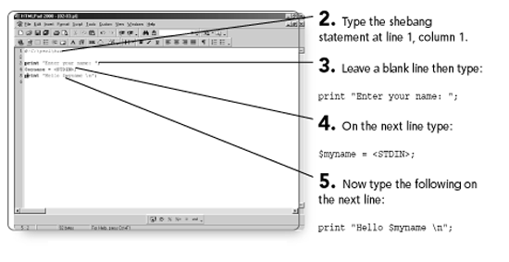
6. Save the program as, say, 02-03.pl.
7. Open an MS-DOS Command box.
Here is the program again with line numbers:
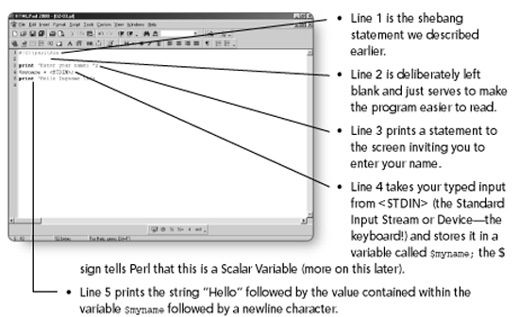

3
Perl Data Types: Scalars
Perl has four built-in data types. They are scalars, arrays, hashes (also known as associative arrays) and references (used for file handles and so on). Scalars are basically single items of data. Arrays are lists of data accessed by means of a numeric subscript, and hashes are lists of data accessed via another scalar variable or literal; arrays and hashes will be covered in later chapters. A reference is a ''pointer" to something else. For example, references are used as "file handles" in order to point to a file (you will examine files in Chapter 12, "Using Files in Perl").
This chapter concerns the scalar data type in Perl. Specifically, you will learn about:
Scalar variables
Strings
The $_ variable
Escape sequences for formatting

Scalar Variables
All scalar variable names are preceded by the dollar sign ($). So, for instance, the variable to hold the age of a person may be written as
$age
If you are not used to languages that use this kind of variable notation, you could easily forget the $ and find some strange errors creeping into your code.
NOTE
Perl variable names are case sensitive. Case-sensitivity is common in modern languages, but do keep it in mind, as it can be the source of some frustration when debugging Perl programs.
Scalar variables are variables that hold a single value. They can be integer, string, floating-point numbers (real numbers), or references. A reference scalar variable is a variable that simply holds the address of another variable; that is, it is a pointer to that variable.
An integer scalar is simply a variable that holds a whole number:
$age = 20;
Page 35
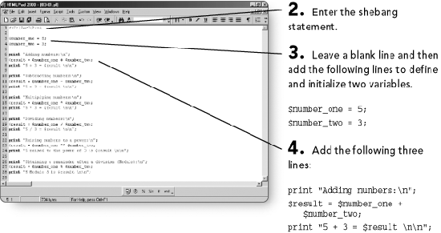
NOTE
Blank lines are optional, but they do help to make the program easier to read. Code that follows on line after line looks a bit crowded. Leaving blank lines between blocks of code that logically belong as a group is easier on the eye and the brain!
NOTE
Note that the variable name, $number, is preceded by a backslash (\) so that the variable is not interpolated (that is, its name is printed rather than its value). At the end of the line the variable is printed, and this time there is no backslash, so the variable is replaced by its value. There are two further newline characters at the end of the line, so there will be two more carriage returns in the displayed output.

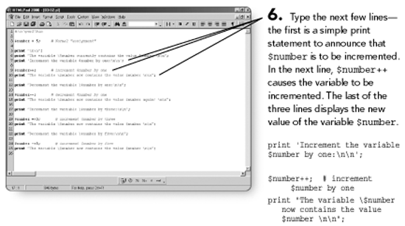
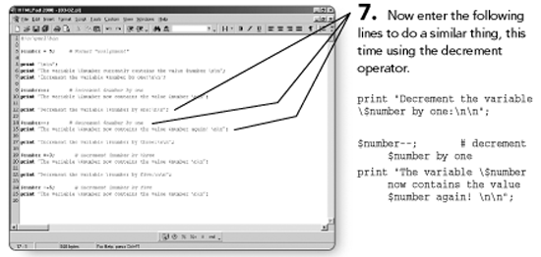
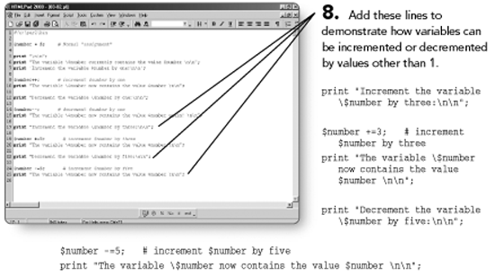

Looking back at your program, note the backslash (\) before the variable name in lines 6, 10, 15, and so on. This is used so that Perl will print $number as a literal and not try to treat it as a variable. Where the $ is not preceded by a backslash you will notice that the value is substituted for the variable name.
There is a slight complication to the increment and decrement assignment operators. This is that they can occur either before or after the variable. The effect of the operator is the same except that when the operator is before the variable, the value of the variable is updated before the variable is used. If the operator is after the variable, the value of the variable is updated after the variable is used. If you are at all familiar with C, C++, Java, PHP, and so on, you will be familiar with this; otherwise it might sound confusing. Don't worry too much about it for now—uses for these techniques will suggest themselves as you get deeper into Perl.

Strings
Strings are also held in scalar variables, for instance, a person's surname might be held in a scalar, like so:
$surname
But remember, a scalar is a scalar. For example, I can also use the $surname variable to hold a number. However, it is not all chaotic. Perl will recognize that you are using a scalar as a number by the action you are carrying out upon it. For example, if you carry out an arithmetic operation upon a numeric scalar you will get a sensible result.
If you do the same on a scalar variable containing a string you will probably get zero. In other words, Perl recognizes a variable type by the context in which it is
used; you will often hear the word context used in conjunction with Perl data types. If you are used to a ''strongly typed" language this will seem a little strange, but you'll soon get used to it.

The $_ Variable
If you use some functions in Perl that require a parameter or argument but do not supply one, Perl will use its special "default" variable. This variable is $_, and it can have many uses as well as being occasionally the source of confusion.
For example, you would normally expect the print statement to have a parameter passed to it—the thing you want printed. If you do not pass a parameter to print, print does not fail, it merely prints the contents of $_.
Try this:
1. Open your editor.
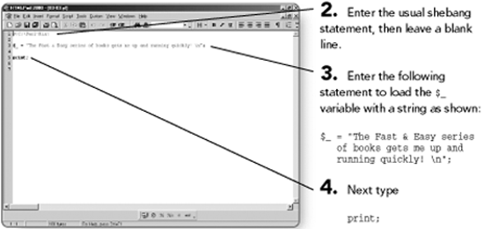
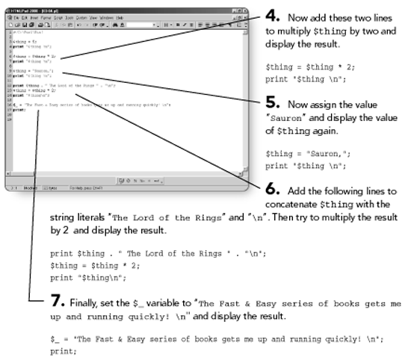

Page 46
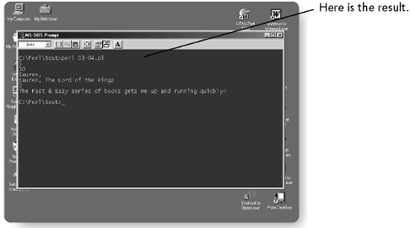
This example shows how scalars can be used for numeric or string values and also what happens when you try to perform arithmetic on a string scalar value.
The last two lines demonstrate the use of the $_ variable. You will use this again as you continue through your exploration of Perl.
Once again, note that the variables in the print statement are enclosed in quotes. Double quotes allow you to interpolate a variable within a string. It is important that you fully understand this mechanism.
$thing = ''Fred";
print "the value of the string is $thing \n";
will give you
the value of the string is Fred
Single quotes work in a similar way for literals, but they do not cause interpolation to occur, and so variables are not evaluated within a string.
In other words, the following code:
$thing = "Fred";
print 'the value of the string is $thing';
will give you
the value of the string is $thing \n
Single quotes cause escape sequences to be ignored. If you put one of the print statements in the previous program in singles quotes, the \n sequences will be displayed and there will be no newlines.
Note that a scalar variable can contain nothing. For example, if you do the following:
print $string1;
$string1 now exists but has no value. However, you can check for the existence of a scalar using the following:
if (defined $string1)
{
print ''That variable has been defined! \n";
}
You can even "uninitialize" a scalar variable like this:
undef($string1);
or
$string1 = undef;
You will be examining more things that you can do with strings in Perl as you come to use strings for real.

Escape Sequences For Formatting
You have already used the print function in Perl. And you recently learned about the use of an escape character \n to give a newline character—that is, to force a line break and move the text cursor to the next line, and \t to give a tab character.
In Chapter 2 you saw a short table of escape sequences. There are a number of other escape sequences that provide text formatting. See Table 3.1 for a more complete list of these common escape sequences.
TABLE 3.1 Escape Sequences
Escape codes | Meaning
\b | Backspace
\n | Newline
\r | Carriage return (go to the beginning of the line)
\t | Tab
\b | Backspace
\u | Convert the next character to uppercase
\U | Convert the following characters to uppercase
\l | Convert the next character to lowercase
\L | Convert the following characters to lowercase
\\ | Display a backslash
\' | Display a single quote
\'' | Display a double quote
\E | End an U or L effect
Note that the backslash can also be used for purposes other than text formatting. For example, what if you want to display a string such as \n or even just a \ ?

You'd place another backslash in front of what you want to print (or to place the string in single quotes). So, if you want to display \n, use
print \\n;
If you want to display a backslash, use
print ''\\";
Also, if you want to display quotes, you can do this:
print "One of the words here has \"quotes\" around it \n";
Now you know how to set up a string value and how to display it. Next you will learn about something that you cannot do much programming without—operators.
Again, like most other languages, you can daisy chain assignments together, so that all variables have the same value and that value is the last one in the chain. (This is often done to set lots of variables at the beginning of a program.)
Try this program.
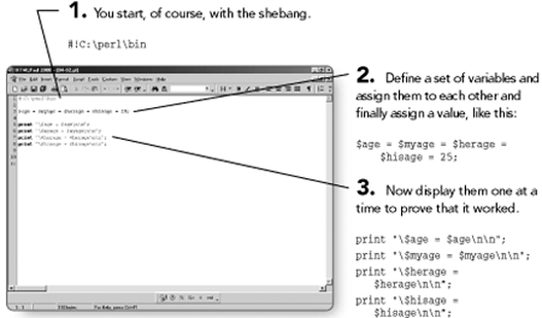
Your program should look like the one shown here.

Other Operators
Perl also supports the increment and decrement operators, as you discovered earlier; now you can take a look at them in a little more detail. These operators are a shorthand way of updating the value of a numeric variable.
$counter++; | # This is the same as: | $counter = $counter + 1;
$counter-; | # This is the same as: | $counter = $counter - 1;
If you want to add more than one to a numeric variable, you can do the following.
$counter+=5; | # This is the same as: | $counter = $counter + 5;
Similarly:
$counter-=5; | # This is the same as: | $counter = $counter - 5;
This shorthand method of updating variables also works with other operators, as shown here:
$counter %=5; | # This is the same as: | $counter = $counter % 5;
(That is, divide $counter by 5, and then place the remainder into $counter.)
$counter*=5; | # This is the same as | $counter = $counter * 5;
By way of a reminder, here is a little program to demonstrate these operators.
Page 62

String Operators
String operators provide you with some useful methods of manipulating strings; with these operators you can join strings together (known as concatenation) or extract ''substrings" from other strings. You will learn about some different string operators in the next sections.

The Concatenation Operator
You can join strings together in Perl using the "dot" (concatenation) operator. Try this example.
1. Open your editor.
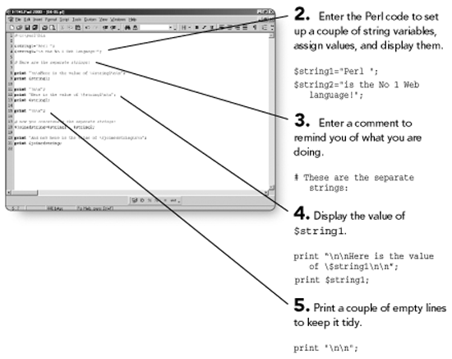
NOTE
It is good practice to do this throughout your programs—you'll be glad you did when you come back later to fix them!
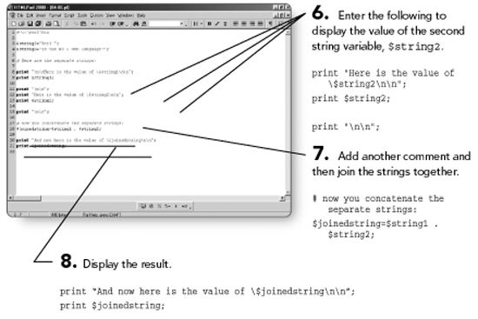
9. Save it as 04-06.pl.
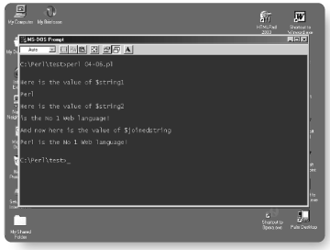
10. Open a command window.
Page 64

Variable Interpolation Revisited
You have learned already about interpolation, wherein if a variable is contained within a string enclosed in double quotes, the variable will be replaced by the value of that variable.
$language = ''Perl";
print "The best Web Programming language is $language \n";
will give you
"The best Web Programming language is Perl"
There are occasions when you want a variable value when interpolated to join up to an adjacent word. Consider the following example:
$something = "comfort";
print "This chair is very $somethingable\n";
This is trying to join $something to the literal part able of the main string. Unfortunately, it will not work, as Perl will try to expand a variable called $somethingable. If you add a space to try to fix it, obviously you'll get a space in the result.
Try this example and prove it to yourself.
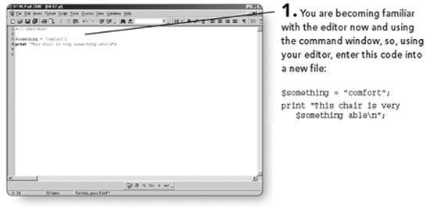
2. Save the code as 04-07.pl.
3. Open a command window.
4. Run your program.
Page 65
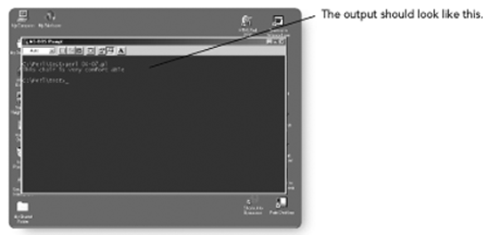
Note that you have a space between comfort and able—that's not what you want!
But Perl has a fix for this. You can wrap your variable name in braces.
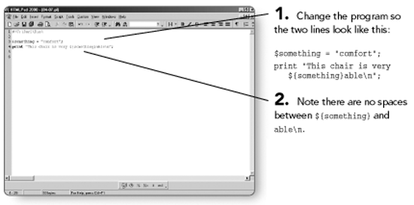
3. Re-save your program.
4. Open a command window.

Substrings
Perl enables you to extract a part of a string and print it or place it in another variable. However, the Perl function that performs the substring action is more sophisticated. The syntax of the function is
substr(stringb, startpos, length)
This means you should obtain the value to be found in stringb; that value being taken from the character at startpos for length number of characters.
If that's confusing, try this small program.
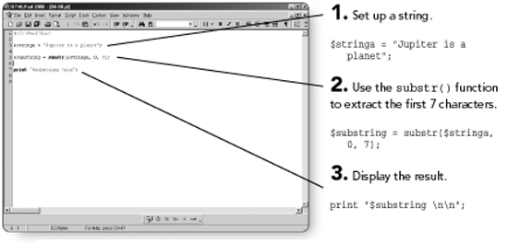
4. Save the program as 04-08.pl.
Very simply, these Perl functions perform the following operations:
• uc. Converts a string to all uppercase.
• lc. Converts a string to all lowercase.
• ucfirst. Converts just the first character of a string to uppercase.
• lcfirst. Converts just the first character of a string to lowercase.
Try this sample program.
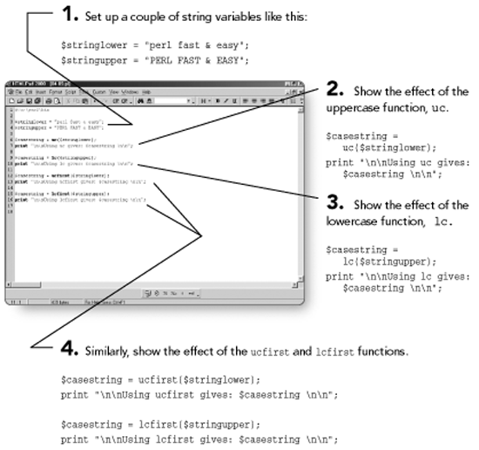

Numeric Comparison Operators
If you are testing numeric scalar values you would use the following comparison operators.
• (>) Greater than
• (==) Equal to
• (<) Less than
• (>=) Greater than or equal to
• (<=) Less than or equal to
• (!=) Not equal to
Page 72
1. Open your editor.
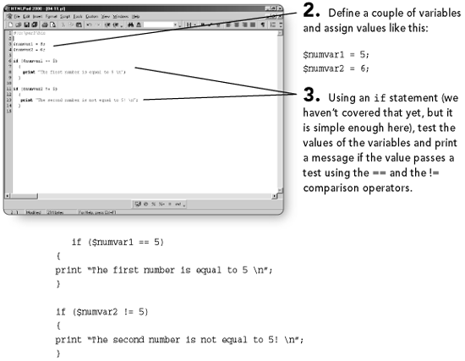
NOTE
The if statement is described in Chapter 7, ''Program Flow," but I hope you have been able to follow the simple if statements used here. If not, return here after reading Chapter 7 and reexamine this code.
4. Save your program as 04-11.pl.
5. Open a command window.

String Comparison Operators
The above operators (==, <, >, and so on) should only be used for testing numeric values. Why? Try the following program, which will demonstrate the difference between numeric comparisons and string comparisons.
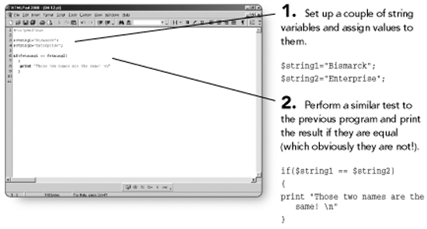
The reason for this is that = = is a numeric comparison operator, and so Perl will interpret $string1 and $string2 as numeric variables. Because Perl will be unable to evaluate them as numbers, they will be set to zero. Therefore, both variables are numerically equal and so the test is passed and the string ''Those two names are the same!" is printed.
For this reason, Perl has a different set of comparison operators for strings.
• eq. Equal to
• ne. Not equal to
• it. Less than
• gt. Greater than
• le. Less than or equal to
• ge. Greater than or equal to
These operators are used in a similar manner to the numeric ones, but obviously only with string variables.
Here is an identical program, except you will be using the string eq comparison operator, and there is an else option to catch the result; otherwise you would see no output.
Page 76
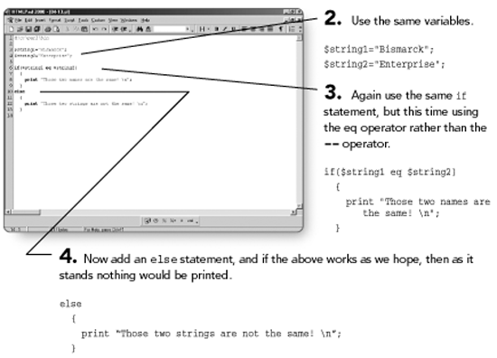
5. Save your program as 04-13.pl.

Logical Operators
The term Boolean comes from the name of a mathematician, George Boole, who pioneered the rules of a logical form of algebra. Computers rely on the logic to work, and so you will often come across the terms True (often represented by the value 1, but can be represented by any non-zero value) and False (often represented by the value zero).
A numeric True value is any non-zero value and, therefore, numeric zero equates to False. So 1, 5, 7, 232, -175, and so on are all True. Only numeric zero is False. We can apply True/False checks to strings, too. The word Olympic is True, a string containing ''0" is True, and a single empty space is True. Only the absence of any alphanumeric characters at all is False.
Page 78
There are basically three logical operators: and, or, and not.
This means that you can check whether two variables have a value simply by doing this:
if ($num1 and $num2)
{
print ''Both of those variables have a non-zero value.\n";
}
Or you can say:
if (not $num1)
{
print "That variable is empty.\n";
}
And you can say:
if ($num1 OR $num2)
{
print "One of those variables has a non-zero value.\n";
}
You can combine conditions such as:
if ($num1 and $num2 or $num3)
{
print "Both of the first variables have a non-zero value or that last one
does!.\n";
}
The logical operators all work in exactly the same way. As you have discovered, the empty string equates to False, and all other values equate to True.
Finally, there are symbols that can be used instead of and, or, and not.
|| is the same as the or logical operator
&& is the same as the and operator
! is the same as the not operator
The only difference between using these instead of the word operators and, or, and not is that the symbol version has a greater precedence. That is, a || will be dealt with before an or. Don't worry about that too much. If you want something evaluated before something else, just enclose the one want you want done first in parentheses.
Logical operators seem simple, but misuse can lead to very confusing errors. You will use logical operators quite a lot later. Try using the previous examples and playing with the code, or just read on and wait for some real examples.
Page 81

5
Arrays
Arrays are simply collections of scalars. The array has a name much like the simple scalar does, but it also has a number of elements. Each element has the same name and is pointed at by a numeric subscript.
In this chapter you will learn about:
Declaring arrays
Loading arrays
Joining arrays
Array function and manipulation
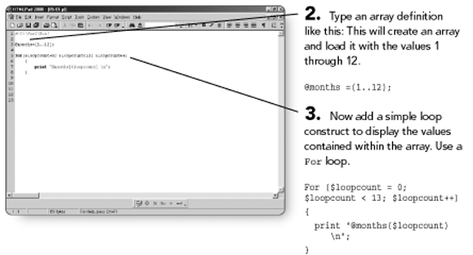
You can have a break in a range when defining an array, like this:
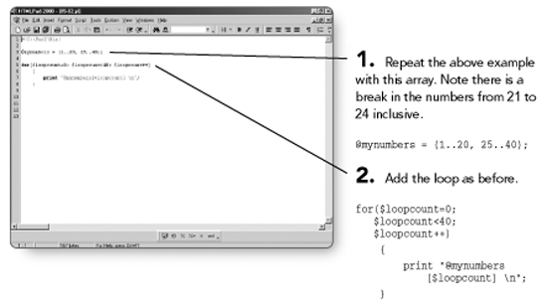
You can do the same thing with characters, like this:
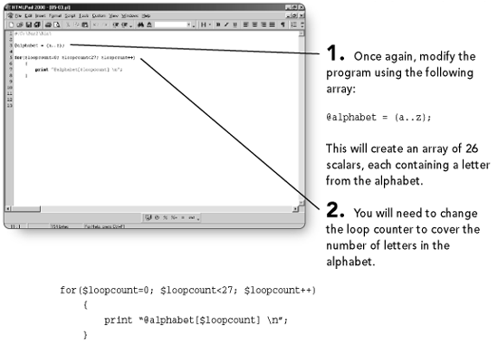

Loading Arrays
There is a lot that you can do with arrays, and many functions are available to manipulate them. Here are a few examples.
Say you have an array called ships. You can load it like this:
@ships=('Bismarck', 'Titanic', 'Hood', );
And you can refer to the individual elements of the array by the use of a numeric subscript like this:
$shipname = @ships[1];

Joining Arrays
You can also join arrays together. If you take two arrays like this:
@warships = ('Hood', 'Bismarck', 'Washington');
@passengerships = ('Titanic', 'Olympic', 'Britannic');
You can join them together like this:
@ships = (@warships, @passengerships);
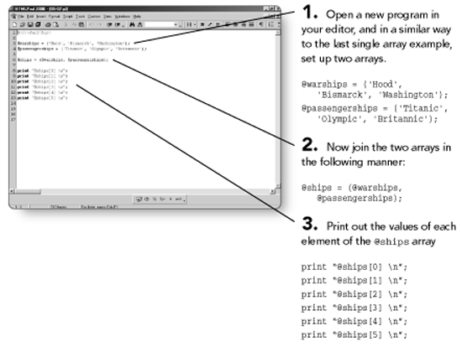

Array Functions and Array Manipulation
Perl arrays are pretty flexible, and really, you have only just scratched the surface of what they can do. There are also lots of built-in functions that are designed to help you manipulate arrays, as you will learn.
Would you like to know how many elements there are in an array? Try this:
print $#ships;
Now try the modified program.
NOTE
If you used the array example you tried a minute ago, you will get a result of 5. (Don't forget that Perl arrays start at element 0, so if there are 6 elements, that will give you a result of 5).
Page 95

6
Hashes
Hashes are sometimes regarded as a difficult subject in Perl. This perception is largely due to the so-called ''misleading and inconsistent" syntax. For this reason, the beginning of this short chapter includes a discussion of what hashes are and how you refer to them in Perl. Hopefully, you will see that hashes are not only useful, but also perfectly logical! You will then learn and practice how to use this powerful data structure. So, read on and bear with me; the short ride will be worth it.
In this chapter you will learn what a hash is and how to use hash prefixes, as well as how to:
Initialize a hash
Create a hash
Load and search hashes
Remove keys from hashes

What are Hashes?
Hashes (sometimes referred to as associative arrays) are similar to ''normal" arrays in as much as they are a list of scalar values. However, the way in which they are accessed is different—the mechanism utilizes "keys" rather than the simple numeric subscript. The important thing to remember about hashes is simply the order in which you quote or specify them, that is, the key and then the value. In most other respects, hashes might be considered a bucket into which you can pour data.
Hashes have a prefix just like scalars and arrays do. For hashes, the prefix is the % symbol. This denotes, when used, that you are referring to the whole hash; if you want to access a single element of a hash you use the $ prefix as you do with arrays. This might seem confusing until you consider that you are only referencing a single scalar within the hash; therefore, you use the scalar notation. Only when you are accessing the whole hash do you use the hash % prefix symbol.
Hashes provide you with a useful lookup mechanism that is a bit like some database tables. A unique key is used to locate a given value. Hashes are uniformly fast; that is, hashes can grow very large with very little degradation in speed, and, as long as your machine has the resources to cope with them, you can make them as large as you like!
Hashes have many uses, not least in Web applications, where they are useful for handling input from HTML forms, CGI environment variables, and other elements, as you will see.

Hash Prefixes
You have just learned that you refer to a hash using the % sign. You will also see the prefixes $ and @ used. Confusing? Well, actually it is quite simple. Always try to think what it is that you are doing with Perl, and all will become clear.
For example, if you are trying to return a single item from a hash, you will see
$item = $hashname{'keyvalue'}
Notice that the hash is using the $ prefix. That makes sense doesn't it? It does, because you are returning a single item, that is, a scalar. Similarly, when you want to return a number of values you use this:
@arrayofvalues = @hashname{'keyvalue1', 'keyvalue2'}
This means: return an array of item values from the given hash that correspond to (in this case) the two key values supplied. You are returning more than one item, so you use the @ prefix. Why? You are returning more than one item into an array.
Just to make it more fun, you can even do this:
@arrayofvalues = @hashname{@arrayofkeys}
Instead of supplying the keys in a list in the braces (yes, those are braces, not parentheses), you supply an array of keys. Still, you are returning a number of values just like in the previous example, so you use the hash name prefixed by @.
Like a lot of things in Perl, at first sight things might seem contradictory or illogical, but when you look at them and think about it, it all makes perfect sense. Perl does force you to think, but you soon realize that if it is logical, it will work in Perl. As you become more proficient in Perl, you will grow ideas of your own and you will be amazed to discover that your logical idea works just fine.
You are now going to try creating and manipulating hashes. It's easier than it seems at first, I promise.

Initializing a Hash
To initialize a hash, simply do this:
%animals = ();
You now have a hash called animals, with no keys or values.
You will try this out in a moment, but let's cover a few more simple hash operations first. You will begin by adding keys and values to a hash.

Creating a Hash
You can add key-value pairs to a hash individually or many at a time. To add elements to a hash you can do something like this:
$animals{'Horse'} = 'Red Rum';
This adds one key-value pair to the hash animals. (Note the $ prefix. As you saw previously, you use the $ prefix because you are accessing a single element of the hash).
If you want to add several at once, you can do so in the following manner:
%animals = ('Red Rum', 'Horse', 'Jaws', 'Shark', 'King Kong', Gorilla);
Now, this is okay, but have you noticed what starts to happen as you read along the list? As you grow the list, imagine what happens when you try to jump into the middle of the list. With the subjects and names you're using here it is fairly obvious which is a key and which is a value. However, in some cases this will not be quite so obvious, and so Perl has another notation that helps you to determine which is which, no matter how long the list. The notation is known as the comma-arrow operator and looks it like this:
%animals = (Horse => 'Red Rum', Shark => 'Jaws', Gorilla => 'King Kong');
Now you can easily see that the => operator is pointing from the key to the data for that pair in the hash. Not only that, but you can now add newline / carriage returns and other whitespace characters and it will still work, so you can make your hash definitions more readable in your programs by using one key-value pair per line, like this:
%animals = (Horse => 'Red Rum',
Shark => 'Jaws',
Gorilla => 'King Kong'
);
This notation is probably called the comma-arrow operator because the => replaces a comma in the previous example. Whatever the reason, the comma-arrow operator makes the pairs easier to identify.
Let's load your first hash.
Page 99

Loading and Searching Hashes
Now you'll learn how to load hashes and how to find data within them. As you are beginning to see, hashes are not much more difficult to use than arrays, and they are very powerful.
1. Open your editor.
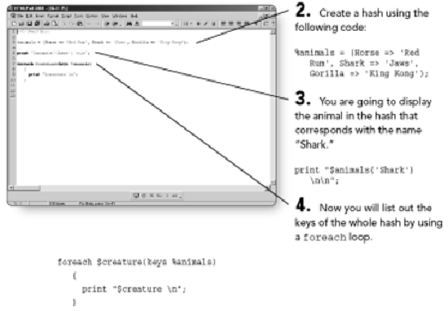
5. Save the program as 06-01.pl.
6. Open a command window.

Removing Keys from a Hash
To remove a single key from a hash, simply use the delete function.
delete($animals{Shark});
Page 101
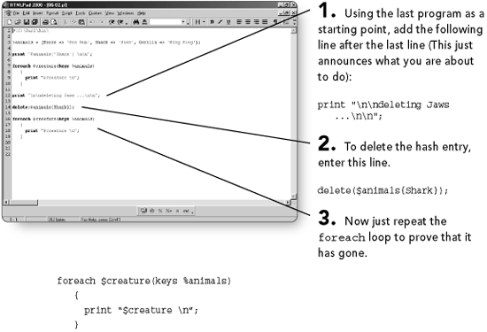
4. Save the program as 06-02.pl.
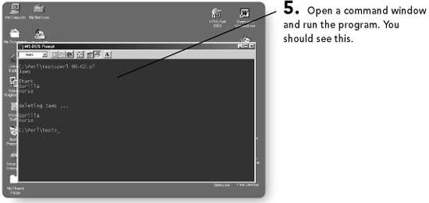
You can also remove all the keys (and values) from a hash, like this:
%animals=();
Notice that you have not really deleted anything. You have just re-initialized the hash, or started it afresh. But the effect is the same.
1. Again taking the previous program as a starting point, add the following lines at the end of the program:
print ''\n\n'emptying' the hash …\n\n";
%animals=();
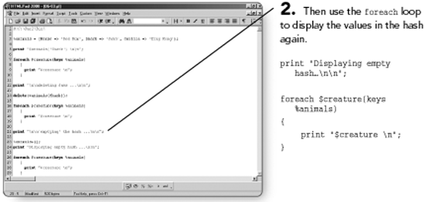
Page 105

7
Program Flow
This chapter will begin with a basic discussion on what program flow is (regardless of the language being used, there is always some kind of flow control in a program). You will then learn how to use flow control to produce the result you want from your Perl programs.
If you are already familiar with basic programming techniques, you may want to skip this short introduction. If you're a Web author branching out into Web development, or someone fairly new to programming who wishes to become a Web developer, you may find this section to be of interest.
In this chapter you will learn:
What program flow is
How program flow works in Perl
How to use the if statement
How to use loops in Perl

The If Statement
The if statement is one of Perl's selection statements. It enables Perl to make decisions based on the values contained in variables.
The if statement in Perl is similar to that in C, C++, and other languages.
If (condition)
{
statement …;
statement …;
}
elsif
{
statement …;
statement …;
}
else
{
statement …;
statement …;
}
Note that often you will find the first curly brace on the same line as the if (condition) part of the statement, like this:
If (condition) {
statement …;
}
Once again, this is just convention and it is up to you whether or not to adopt it. If you are not working to any set rules within an organization, just be consistent. Otherwise you might confuse people who attempt to maintain or learn from your program.
The elsif/else part of the if construct is optional. You might not need one; in fact, often you will not. Also note that spelling of elsif.
You can also have if statements within if statements or within else clauses, and you will come across many differing examples. You have leaned the basic syntax of the if statement, so now it is time to try one out. You have actually seen this example before, but it won't hurt to cover it again.
1. Open your editor.
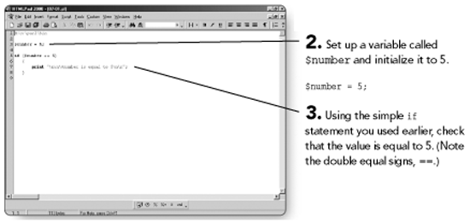
if ($number == 5)
{
print ''\n\n\$number is equal to 5\n\n";
}
That was a simple if statement. Here is an if statement using the full if statement syntax.
1. Open your editor.
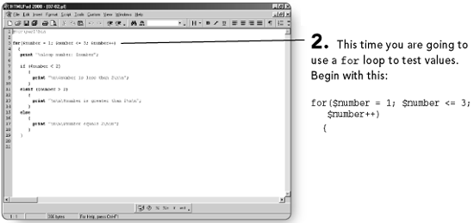
Page 110
NOTE
This sets the value of $number to 1; then, do whatever is in the loop (between the following curly braces) as long as $number<= 3. $number++ increments the value of $number on each execution of the loop.
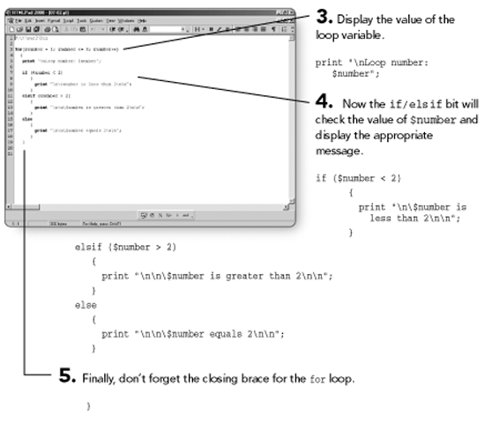
6. Save the code as 07-02.pl.
7. Open a command window and run the program.

Loops in Perl
Perl is fairly rich in its loop facilities. Perl can loop while a condition is True. It can loop until a condition is True. Perl can do a loop while or until a condition is True or False, performing the loop at least once. Finally, Perl can loop a predetermined number of times using the for loop. Next you will learn how to use each of these loop structures.

The while and until Loops
The while loop runs a loop as long as a given condition is True. If the condition specified is not True to begin with, the code within the while loop is never executed. The while loop looks like this:
While (condition)
{
statement …;
statement …;
}
NOTE
Note that again you will often see the opening brace on the same line as the while (condition)—it is just another convention.
Page 112
The until loop is very similar to the while loop. As the names of these loops suggest, the while loop continues to loop while a given condition is satisfied, whereas the until loop continues to loop until a condition arises.
Here is an example with both types of loops.
1. Start a new program in your editor.
2. Announce what you are going to do (this is optional, of course).
print ''The While Loop:\n";
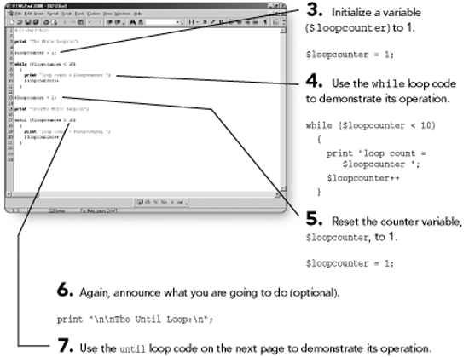
Page 112
The until loop is very similar to the while loop. As the names of these loops suggest, the while loop continues to loop while a given condition is satisfied, whereas the until loop continues to loop until a condition arises.
Here is an example with both types of loops.
1. Start a new program in your editor.
2. Announce what you are going to do (this is optional, of course).
print ''The While Loop:\n";
Both of the loops in this example are similar to the preceding while and until loops, but as has already been stated, the main difference is that the loop in the do versions is executed at least once.

The For Loop
This is similar to the C/C++ for loop. The format of the for loop is
for(loop_variable = initial_value; loop_termination_condition;
loop_variable_update)
The syntax begins with the keyword for, followed by an open bracket, and then the initial condition of the for statement, followed by the test that determines whether the loop should finish or not, followed by the update to the variable being tested. Often this is an increment, but it can also be a decrement value. Finally, there is the closing bracket. Then there is the block of code to be executed while the test condition allows.
Following is an example of the Perl for loop.
Page 116
1. Open a new program in your editor.
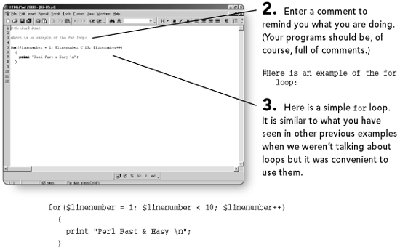
4. Save the program as 07-05.pl.
5. Open a command window and run the program.
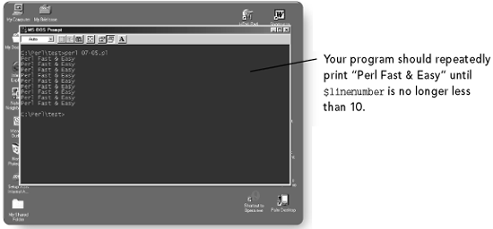
The increment can also be a decrement, so you might see this instead:
for($linenumber = 1;
$linenumber < 10;
$linenumber-)
Page 116
You will sometimes see odd implementations of for loops. Try this one:
for(;;)
{
print ''Perl Fast & easy \n";
}
This loop has no initialized variable, no test, and no update of any test variable, so it will loop forever. Often, this means that you don't always know under what conditions the loop should terminate, and so this technique is sometimes used to allow you a different method of deciding when you should break out of the loop. An unusual use of this type of loop, but it serves to illustrate the flexibility of the Perl for loop.
We have discussed the data types used in Perl and given a few examples of how they can be used. You have also learned the syntax of some program flow processing elements of the Perl language. There is more to learn in these respects, and you will be extending your knowledge of the language as you need to. The rest of this book will provide much of that knowledge; your own experience and looking at the work of others (who were once where you are now) will fill in the gaps and extend your experience.
Page 119

8
Perl Functions
Perl is a very function-rich language. In this chapter you will explore many of the functions that Perl provides, especially those that help you with your Web applications. Some functions are found in many languages, others are unique to Perl; after you've learned to use them, you'll wish that all languages provided the same facilities.
In this chapter you will learn how to use:
String functions
Array functions
Hash functions
Subroutines

